Exploratory Data Analysis

Zomato

Vishal Kumar Lal

# FEATURES

# 

## tOP user of zomato A

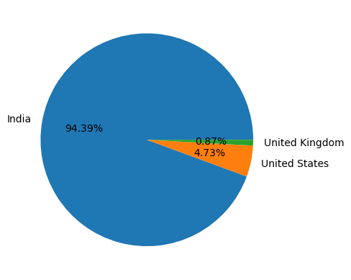

## Distribution across the cities of india

